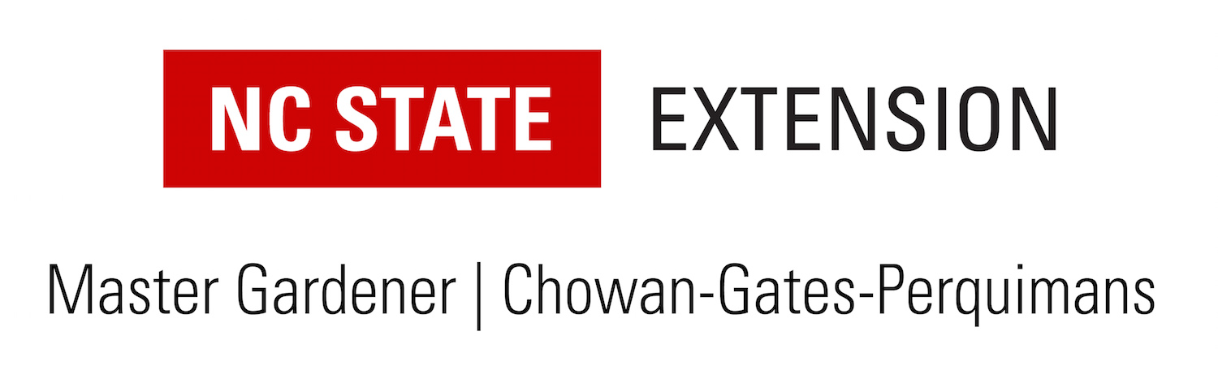

Dear Friends,
The Chowan, Gates and Perquimans Volunteer Master Gardeners are pleased to continue our scholarship opportunity. It will be awarded in the Spring of 2024 to help a student who plans to study or is currently studying in a qualifying field.
The main focus of our Master Gardener program is to enhance public education in consumer horticulture. As a natural extension of our program, we now offer a scholarship in the areas of horticulture, agriculture, natural resources or a related field. The financial backing for this scholarship is received from our annual Spring Garden Show, currently held at the Perquimans County Recreation Center. Since the show’s inception, we have repeatedly received enthusiastic support from both the participating vendors and the general public.
Our scholarship, The Katherine G. Shook Master Gardener Scholarship, consists of a $1,000 award. If a winner maintains a 2.5 overall GPA and a 3.0 GPA in the qualifying area of study, he or she is eligible to reapply for continued support.
Katy Shook was the N.C. Cooperative Extension Consumer Horticulture Agent for Chowan, Gates and Perquimans counties from 2003 to 2023 and was instrumental in establishing and maintaining the Master Gardener program. Katy’s leadership, knowledge and infectious enthusiasm has impacted our youth (Jr. Master Gardener Program and various elementary school programs) as well as countless residents within the three counties.
Our scholarship committee is looking forward to working with you. We hope you will help distribute information about the award and encourage qualified applicants to apply.
Sincerely,
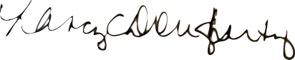

Nancy Dougherty, Scholarship Committee Chair

The Katherine G. Shook Master Gardener Scholarship
GUIDELINES
Amount:
- $1,000
Eligibility:
- HS seniors or college students residing in Chowan, Gates or Perquimans counties
- Students attending an accredited public, private or parochial school, or enrolled in a state approved homeschool
- Acceptance to or enrollment in a 2-year or 4-year accredited college program in a qualifying field of study

Criteria:
- HS Students 3.0 GPA or above
- College Students must maintain a 2.5 overall GPA and a 3.0 GPA in a qualifying area of study
- Volunteer experience through paid or unpaid work or extracurricular activities
- Qualifying fields of study include horticulture, agriculture, natural resources or a related field
Required Documentation:
- Official transcript from current school
- Acceptance letter from school you plan to attend (or are attending, if college student)
- Completed application form
- Completed essay
- Two signed and sealed letters of recommendation, one from an educator and one from a non-related adult
Process:
- All documents must be received in one packet on or before April 5, 2024.
- Top finalists may be interviewed by members of the Master Gardener Scholarship Committee
- Scholarship award will be payable directly to the accredited college or university

Additional Information:
- Return All Documents to:
Chowan, Gates & Perquimans Volunteer Master Gardeners
730 N Granville St, Ste A
Edenton, NC 27932
- If you have any questions, please leave a message with the Chowan Cooperative Extension office (482-6585) and the scholarship chairperson will return your call as soon as possible. Thank you.
The Katherine G. Shook Master Gardener Scholarship
ESSAY FORM
Please complete an essay of 250 words or less on one of the following questions:
- What do you feel qualifies you to receive this scholarship?
- What are your career goals after you graduate from college?
- How will your education have an impact on your community?

_________________________________________________________________________________________________________________________________________________________________________________________________________________________________________________________________________________________________________________________________________________________________________________________________________________________________________________________________________________________________________________________________________________________________________________________________________________________________________________________________________________________________________________________________________________________________________________________________________________________________________________________________________________________________________________________________________________________________________________________________________________________________________________________________________________________________________________________________________________________________________________________________________________________________________________________________________________________________________________________________________________________________________________________________________________________________
__________________________________________________________________________________________________________________________________________________________________

The Katherine G. Shook Master Gardener Scholarship
APPLICATION
Applicant Information
Full Name: ____________________________________________________________
Last First M.I.
Home Address: _____________________________________________________________
Street Address Apartment/Unit #
_____________________________________________________________
City State Zip County
Home Phone: ( )____________________ Cell Phone: ( )________________

School Information
Current School: ____________________________________ GPA: ___________
College you plan to attend: _______________________________________________________
Address: _______________________________________________________
ATTACH A COPY OF YOUR LETTER OF ACCEPTANCE
Your Intended Major (Check one):
⃝ Horticulture ⃝ Agriculture
⃝ Natural Resources ⃝ Related Field of Study
________________________
Will enter college as (check one):
⃝ Freshman ⃝ Sophomore
⃝ Junior ⃝ Senior

Additional Information – Use an additional sheet if necessary.
List school and community organizations and/or activities which you have participated in during the last 4 years:

List school related awards, honors, scholarships received:

Personal Data (e.g. background, interests):
Application Checklist
All of the following requirements must be included in one packet in order to be considered for The Katherine G. Shook Master Gardener Scholarship:
- Official transcript from current school
- Letter of acceptance from school you plan to attend (or are attending, if college student)
- Completed application form
- Completed essay
- Two signed and sealed letters of recommendation, one from an educator and one from a non-related adult
- Return required items by April 5, 2024 deadline
Chowan, Gates & Perquimans Master Gardener Volunteers
Att: Scholarship Committee
730 N. Granville St. Suite A
Edenton, NC 27932
I understand that an incomplete application will be removed from further review.
I acknowledge that information provided on this application is complete and truthful. I understand that all submitted materials will become the property of the scholarship committee and will not be returned. I agree that it will be left to the discretion of the scholarship committee to determine whether a scholarship is awarded.

Signed: ____________________________________________ Date:____________________

